MEDIBOT: Context-Aware Personalized Medical
RAG System with CNN-Based Lung Disease Detection

and Offline-First Clinical Intelligence

A PROJECT REPORT

PRAKHAR SHARMA [RA2211003011017]
KARTAVYA ADLAKHA [RA2211003011007]

Under the Guidance of
Dr. GEETHA K
Assistant Professor,
Department of Computing Technologies

in partial fulfillment of the requirements for the degree of

BACHELOR OF TECHNOLOGY

in

COMPUTER SCIENCE ENGINEERING

with specialization in CSE CORE


DEPARTMENT OF COMPUTING TECHNOLOGIES COLLEGE OF ENGINEERING AND TECHNOLOGY
SRM INSTITUTE OF SCIENCE AND TECHNOLOGY

KATTANKULATHUR- 603 203

MAY 2026


Department of Computing Technologies

SRM Institute of Science & Technology

Own Work Declaration Form

This sheet must be filled in (each box ticked to show that the condition has been met). It must be signed and dated along with your student registration number and included with all assignments you submit – work will not be marked unless this is done.
To be completed by the student for all assessments

Degree/ Course : B. Tech in Computer Science and Technology

Student Name : Prakhar Sharma, Kartavya Adlakha

Registration Number : RA221100301101, RA2211003011007

Title of Work : MediBOT: Context-Aware Personalized Medical RAG System with CNN-
Based Lung Disease Detection and Offline-First Clinical Intelligence
I / We hereby certify that this assessment compiles with the University’s Rules and Regulations relating to Academic misconduct and plagiarism, as listed in the University Website, Regulations, and the Education Committee guidelines.

I / We confirm that all the work contained in this assessment is my / our own except where indicated, and that I / We have met the following conditions:

- Clearly referenced / listed all sources as appropriate
- Referenced and put in inverted commas all quoted text (from books, web, etc)
- Given the sources of all pictures, data etc. that are not my own
- Not made any use of the report(s) or essay(s) of any other student(s) either past or present
- Acknowledged in appropriate places any help that I have received from others (e.g. fellow students, technicians, statisticians, external sources)
- Compiled with any other plagiarism criteria specified in the Course handbook / University website
I understand that any false claim for this work will be penalized in accordance with the University policies and regulations.

DECLARATION:
I am aware of and understand the University’s policy on Academic misconduct and plagiarism and I certify that this assessment is my / our own work, except where indicated by referring, and that I have followed the good academic practices noted above.

Prakhar Sharma Kartavya Adlakha
If you are working in a group, please write your registration numbers and sign with the date for every student in your group.



SRM INSTITUTE OF SCIENCE AND TECHNOLOGY

KATTANKULATHUR – 603 203

BONAFIDE CERTIFICATE

Certified that 21CSP401L - Project report titled “MEDIBOT” is the bonafide work of “PRAKHAR SHARMA [RA2211003011017], KARTAVYA ADLAKHA [RA2211003011007]” who carried out the project work under my supervision. Certified further, that to the best of my knowledge the work reported herein does not form any other project report or dissertation on the basis of which a degree or award was conferred on an earlier occasion on this or any other candidate.

SIGNATURE  Dr. Geetha K  SUPERVISOR  Assistant Professor  DEPARTMENT OF  COMPUTING TECHNOLOGIES |  | SIGNATURE  Dr. Niranjana G  PROFESSOR &HEAD  DEPARTMENT OF  COMPUTING TECHNOLOGIES

Examiner 1 Examiner 2

ACKNOWLEDGEMENTS
We express our humble gratitude to Dr. C. Muthamizhchelvan, Vice-Chancellor, SRM Institute of Science and Technology, for the facilities extended for the project work and his continued support.
We extend our sincere thanks to Dr. Leenus Jesu Martin M, Dean-CET, SRM Institute of Science and Technology, for his invaluable support.
We wish to thank Dr. Revathi Venkataraman, Professor and Chairperson, School of Computing, SRM Institute of Science and Technology, for her support throughout the project work.
We encompass our sincere thanks to, Dr. M. Pushpalatha, Professor and Associate Chairperson - CS, School of Computing and Dr. C. Lakshmi, Professor and Associate Chairperson -AI, School of Computing, SRM Institute of Science and Technology, for their invaluable support.
We are incredibly grateful to our Head of the Department, Dr. Niranjana G, Department of Computing Technologies, SRM Institute of Science and Technology, for her suggestions and encouragement at all the stages of the project work.
We want to convey our thanks to our Project Coordinators, Panel Head, and Panel Members Department of Computational Intelligence, SRM Institute of Science and Technology, for their inputs during the project reviews and support.
We register our immeasurable thanks to our Faculty Advisor, Dr. M Kandan, Department of Computing Technologies, SRM Institute of Science and Technology, for leading and helping us to complete our course.
Our inexpressible respect and thanks to our guide, Dr. Geetha K, Department of Computing Technologies, SRM Institute of Science and Technology, for providing us with an opportunity to pursue our project under his / her mentorship. He / She provided us with the freedom and support to explore the research topics of our interest. His / Her passion for solving problems and making a difference in the world has always been inspiring.
We sincerely thank all the staff members of Department of Technologies, School of Computing, S.R.M Institute of Science and Technology, for their help during our project. Finally, we would like to thank our parents, family members, and friends for their unconditional love, constant support and encouragement
Prakhar Sharma,
Kartavya Adlakha

ABSTRACT

Access to timely clinical guidance in rural and underserved regions is often hindered by the absence of specialists, unreliable internet, and poorly digitized patient records. To address these barriers, this project presents MediBOT, a context-sensitive personalized medical platform that fuses Retrieval-Augmented Generation (RAG), deep-learning-driven analysis of chest radiographs, and OCR-based digitization of paper reports inside an offline-first Progressive Web Application. What distinguishes the system is its patient-context injection mechanism: demographic details, blood group, known allergies, currently prescribed medications, and recent vital signs are serialized into the prompt prior to retrieval and generation, allowing the model to produce medically tailored and contraindication-aware answers rather than generic chatbot replies. Architecturally, the platform is organized into three tiers — a React-Vite-Tailwind PWA frontend with IndexedDB persistence, a FastAPI middleware responsible for validation and routing, and an ML backend that combines Llama-2 7B, FAISS, sentence-transformer embeddings, ResNet101, and EasyOCR. The proposed CNN component categorizes chest X-rays across five lung-disease classes with roughly 84% test accuracy, while the OCR pipeline recovers structured allergies, medications, and vitals from scanned or photographed documents. Taken together, the system illustrates how context-aware medical reasoning, offline-first persistence, and multi-modal AI can be unified into a clinically deployable support tool for resource-limited environments.

v
TABLE OF CONTENTS
ABSTRACT v
TABLE OF CONTENTS vi
LIST OF FIGURES viii
LIST OF TABLES ix
ABBREVIATIONS x

CHAPTER NO. TITLE PAGE NO.
1 INTRODUCTION 1
1.1 Introduction to Project 1
1.2 Problem Statement 1
1.3 Motivation 1
1.4 Sustainable Development Goal of the Project 2
2 LITERATURE SURVEY 3
2.1 Overview of the Research Area 3
2.2 Existing Models and Frameworks 5
2.3 Limitations Identified from Literature Survey (Research Gaps) 6
2.4 Research Objectives 7
2.5 Product Backlog (Key user stories with Desired outcomes) 7
2.6 Plan of Action (Project Road Map) 7
3 SPRINT PLANNING AND EXECUTION METHODOLOGY 9
3.1 SPRINT 1 9
3.1.1 Objectives with user stories of Sprint I 9
3.1.2 Functional Document 10
3.1.3 Architecture Diagram 11
3.1.4 Outcome of Objectives 11
3.1.5 Sprint Retrospective 12
3.2 SPRINT 2 13
3.2.1 Objectives with user stories of Sprint II 13
3.2.2 Functional Document 14
3.2.3 Outcome of Objectives 14
4 RESULTS AND DISCUSSIONS 15
4.1 Project Outcomes (Performance Evaluation, Comparisons, Testing Results) 16
5 CONCLUSION AND FUTURE ENHANCEMENT 19

REFERENCES 22
APPENDIX 23
A CODING 23
B PAPER SUBMISSION 25
C PLAGIARISM REPORT 26

vi
LIST OF FIGURES
CHAPTER NO. TITLE PAGE NO.
2.5 Product Backlog 8
2.6 Release Plan 8
3.1.3 Architecture Diagram 11
3.1.5 Sprint Retrospective 12
4.1 Patient Dashboard UI 17
4.2 AI Diagnostic Lab - Chest X-Ray Analysis 18
4.3 MediBOT Personalized Chat Interface 18
4.4 CNN Training Accuracy Curves 19
5.1 Three-Tier Architecture Diagram 22
5.2 Confusion Matrix 22
B.1 Paper Submission Confirmation 26
C.1 Plagiarism Report 27

viii

LIST OF TABLES
CHAPTER NO. TITLE PAGE NO.
2.1 Survey of Previous Works 3
2.2 Comparative Table of Existing Models 6
3.1.4 Outcome of Objectives 11
5.1 Comparison with Generic AI Systems 20

ix

ABBREVIATIONS
Abbreviation Full Form
AI Artificial Intelligence
RAG Retrieval-Augmented Generation
CNN Convolutional Neural Network
NLP Natural Language Processing
LLM Large Language Model
OCR Optical Character Recognition
PWA Progressive Web Application
FAISS Facebook AI Similarity Search
API Application Programming Interface
UI User Interface
GUI Graphical User Interface
GPU Graphics Processing Unit
ResNet Residual Neural Network
FHIR Fast Healthcare Interoperability Resources
ReLU Rectified Linear Unit
AUC Area Under the Curve
ROC Receiver Operating Characteristic
PDF Portable Document Format
JSON JavaScript Object Notation
CORS Cross-Origin Resource Sharing

x

CHAPTER 1
INTRODUCTION
1.1 Introduction to Project
In rural and underserved regions, healthcare delivery continues to suffer from limited specialist availability, slow diagnostic turnaround, fragmented medical records, and unreliable network connectivity. To compensate, patients often turn to generic web searches or mainstream chatbot services, yet these tools rarely account for clinically important factors such as known allergies, ongoing prescriptions, blood group, or recent vital measurements. Within a medical context, such generic guidance is not merely unhelpful — it can be outright dangerous when contraindications or emergency indicators go unnoticed.
To address these challenges, this project introduces MediBOT, a context-sensitive personalized medical platform that fuses Retrieval-Augmented Generation (RAG), deep-learning-driven analysis of chest radiographs, and OCR-based digitization of paper reports inside an offline-first Progressive Web Application. In contrast to conventional medical chatbots, MediBOT embeds patient-specific clinical details directly inside the RAG prompt, so that the language model can yield personalized and contraindication-sensitive responses. The system integrates textual reasoning with CNN-driven chest X-ray classification and OCR-assisted report structuring inside a unified platform, making it a comprehensive clinical decision support tool.
The healthcare landscape in developing countries is marked by a severe imbalance between the demand for specialist medical services and the available supply of qualified practitioners. According to the World Health Organization, approximately half of the global population lacks access to essential health services, with the deficit being most acute in rural and semi-urban regions. In such environments, patients frequently rely on informal consultations, unverified internet resources, or delayed referrals to distant hospitals, all of which contribute to misdiagnosis, treatment delays, and preventable morbidity.
Artificial intelligence, and in particular large language models combined with retrieval-augmented generation, offers a transformative opportunity to bridge this gap. By grounding language model outputs in curated medical knowledge bases, RAG systems can provide evidence-based clinical guidance without the hallucination risks inherent in purely generative approaches. However, the vast majority of existing medical AI systems treat every patient identically, ignoring the clinically critical differences in allergies, current medications, blood type, and recent vital signs that should fundamentally shape any medical recommendation.
MediBOT addresses this shortcoming through a patient-context injection mechanism that serializes the individual's clinical profile into the generation prompt before retrieval and response synthesis. This ensures that every response is not only medically grounded but also personalized to the specific patient's clinical situation. The system further extends its utility by integrating a convolutional neural network for chest X-ray classification and an optical character recognition pipeline for digitizing paper-based medical reports, all within an offline-capable Progressive Web Application architecture.
The platform is architected as a three-tier system comprising a React-based frontend with IndexedDB persistence via Dexie.js, a FastAPI middleware layer responsible for request validation, rate limiting, and cross-origin resource sharing, and a machine learning backend that orchestrates Llama-2 7B inference, FAISS vector retrieval, ResNet101 image classification, and EasyOCR text extraction. This layered design ensures separation of concerns, independent scalability of each tier, and the ability to swap individual components such as the language model or the embedding strategy without disrupting the overall system.
1.2 Problem Statement
Healthcare access in resource-limited environments is severely constrained by the shortage of medical specialists, poor internet connectivity, and the prevalence of paper-based medical records. Existing medical chatbot systems provide generic responses that do not account for individual patient profiles including allergies, current medications, blood group, and vital signs. This creates a risk of delivering medically unsafe advice. Furthermore, diagnostic tools for chest radiography remain inaccessible in rural clinics that lack on-site radiologists. Paper-based reports are difficult to digitize and integrate into digital workflows. There is a critical need for a unified platform that can provide personalized medical question answering, automated chest X-ray analysis, and report digitization while remaining functional under intermittent or absent network connectivity.
The problem is further compounded by the fragmentation of clinical workflows across disconnected systems. A typical patient in a resource-limited setting may have paper-based prescriptions from one clinic, handwritten lab reports from another, and no centralized digital record linking these documents. When such a patient seeks AI-powered medical guidance, existing systems have no mechanism to incorporate this fragmented history into their reasoning process.
Additionally, the reliance on cloud-based inference for medical AI creates a fundamental accessibility paradox: the populations that stand to benefit most from AI-powered clinical guidance are precisely those with the least reliable internet connectivity. A system that becomes non-functional during network outages provides no value in the very scenarios where it is most needed. This necessitates an offline-first architectural approach where critical data and functionality remain available regardless of connectivity status.
The challenge of medical image interpretation in underserved areas is equally pressing. While chest radiography is one of the most cost-effective screening modalities for pulmonary diseases, the interpretation of X-ray images requires specialized radiological expertise that is scarce in rural settings. An automated classification system that can provide preliminary screening results with confidence scores and severity assessments can serve as a valuable decision support tool for frontline healthcare workers who lack access to specialist radiologists.
1.3 Motivation
The motivation for this project comes from the critical healthcare gaps that exist in underserved communities. Although chest radiography is among the most widely used modalities for screening pulmonary conditions such as pneumonia, tuberculosis, pneumothorax, and COVID-19, many rural clinics operate without on-site radiologists. Compounding this, paper-based reports remain prevalent, which turns clinical data extraction into a slow, manual, and error-prone exercise.
Another key motivation is the limitation of existing medical AI systems that function as generic knowledge retrieval tools without considering the patient’s specific medical context. When a system ignores known allergies or current medications while providing medical advice, it creates a genuine safety risk. This project aims to bridge this gap by developing a system that is not only medically knowledgeable but also patient-aware, ensuring that every response accounts for the individual’s clinical profile. The offline-first design further ensures that the system remains functional in the very environments where it is needed most.
Furthermore, the global COVID-19 pandemic has underscored the urgent need for accessible diagnostic tools that can operate at scale without requiring physical visits to overcrowded healthcare facilities. The pandemic demonstrated that AI-powered screening tools for respiratory conditions can significantly reduce the burden on healthcare systems by triaging patients who require immediate attention from those who can be monitored remotely.
The convergence of several technological advances makes this project particularly timely. Transfer learning has reduced the data requirements for training accurate medical image classifiers; quantized language models can now run on consumer-grade hardware; vector similarity search enables efficient retrieval from large medical knowledge bases; and Progressive Web Application standards provide a robust framework for offline-capable web applications. MediBOT leverages all of these advances to create a system that would have been impractical even two years ago.
From an ethical standpoint, the project is motivated by the principle that access to reliable medical guidance should not be contingent on geographic location or economic status. By designing a system that works offline, personalizes its responses to individual clinical profiles, and provides transparent source citations for its recommendations, MediBOT aims to democratize access to clinical intelligence while maintaining the safety standards expected of healthcare technology.
1.4 Sustainable Development Goal of the Project
This project is aligned with the United Nations Sustainable Development Goal 3: Good Health and Well-Being, which aims to ensure healthy lives and promote well-being for all at all ages. By providing AI-powered clinical decision support that works offline and personalizes medical advice based on patient context, MediBOT directly addresses healthcare access barriers in rural and underserved communities. The system’s chest X-ray classification capability extends diagnostic reach to areas without radiologists, while the OCR-based report digitization modernizes paper-based healthcare workflows. Overall, the project contributes to making quality healthcare guidance more accessible, equitable, and reliable across resource-constrained environments.
Specifically, the project addresses SDG Target 3.8, which focuses on achieving universal health coverage, including access to quality essential healthcare services and access to safe, effective, quality, and affordable essential medicines. By providing AI-powered diagnostic screening and personalized medical guidance through an offline-capable platform, MediBOT extends the reach of quality healthcare services to populations that are currently underserved.
The project also contributes to SDG Target 3.d, which calls for strengthening the capacity of all countries for early warning, risk reduction, and management of national and global health risks. The chest X-ray classification system enables early detection of conditions such as tuberculosis and pneumonia, which remain leading causes of mortality in developing countries. Early detection through automated screening can significantly improve treatment outcomes and reduce the spread of communicable diseases.
Additionally, the offline-first design philosophy aligns with SDG Target 9.c, which advocates for significantly increasing access to information and communications technology. By ensuring that the platform functions without continuous internet connectivity, MediBOT removes a critical barrier to technology adoption in regions where network infrastructure remains underdeveloped.
CHAPTER 2
LITERATURE SURVEY
2.1 Overview of the Research Area
Medical AI and clinical decision support systems have become rapidly growing research areas due to advancements in large language models, retrieval-augmented generation, and deep learning-based medical imaging. The emergence of models like GPT-4, Llama-2, and Med-PaLM has demonstrated that language models can encode significant clinical knowledge when properly grounded with domain-specific retrieval and prompting strategies.
Retrieval-Augmented Generation (RAG) has emerged as a key technique for reducing hallucinations in LLM-based systems by consulting relevant documents before generation. However, most general-purpose RAG deployments are knowledge-centric rather than patient-centric — they retrieve textbook content effectively but rarely treat allergies, medication conflicts, or live vital signs as first-class inputs that shape the response. This shortcoming is particularly limiting for frontline healthcare applications.
Within medical imaging, transfer learning applied to deep residual networks remains a robust baseline for classifying chest radiographs. Work such as CheXNet has shown that deep convolutional architectures can rival expert performance in thoracic disease detection. OCR-based digitization has also attracted attention for handling scanned medical documents, with tools like EasyOCR providing usable multilingual OCR. However, most existing pipelines fail to feed extracted data back into a personalized reasoning pipeline. Finally, offline-first healthcare software remains rare despite being essential for remote care settings.
The convergence of natural language processing, computer vision, and clinical informatics has created a fertile landscape for AI-driven healthcare applications. Language models such as GPT-4, Llama-2, and Gemini have demonstrated remarkable capabilities in understanding and generating medical text, yet their deployment in clinical settings requires careful consideration of grounding, personalization, and safety.
Retrieval-Augmented Generation represents a paradigm shift in how language models access and utilize domain knowledge. Unlike fine-tuning, which permanently encodes knowledge into model parameters, RAG dynamically retrieves relevant documents at inference time, ensuring that responses are grounded in verifiable sources. This is particularly valuable in healthcare, where medical knowledge evolves rapidly and the ability to trace recommendations back to authoritative sources is a fundamental requirement for clinical trust.
The embedding models used for retrieval, such as sentence-transformers and MiniLM variants, convert medical text into dense vector representations that capture semantic similarity. Facebook AI Similarity Search provides efficient nearest-neighbor lookup in these vector spaces, enabling sub-millisecond retrieval even from knowledge bases containing millions of document chunks. The combination of dense retrieval with generative language models creates a system that is both knowledgeable and articulate, capable of synthesizing information from multiple sources into coherent clinical guidance.
In the domain of medical imaging, deep learning has revolutionized automated diagnosis. Convolutional neural networks, particularly those based on residual architectures such as ResNet, have achieved expert-level performance on tasks including chest X-ray classification. The key insight behind transfer learning is that low-level visual features learned on large-scale datasets like ImageNet transfer effectively to medical imaging tasks, dramatically reducing the amount of labeled medical data required for training.
Optical character recognition has evolved from simple template-matching approaches to sophisticated deep learning pipelines. EasyOCR, built on CRAFT text detection and recognition networks, provides a practical solution for extracting text from photographed medical documents. When combined with zero-shot extraction capabilities of large language models, OCR becomes a powerful tool for converting unstructured medical documents into structured clinical data.
Author(s) | Title | Year | Techniques & Findings
Singhal et al. [1] | Large language models encode clinical knowledge | 2023 | Demonstrated LLMs encode significant clinical knowledge with proper prompting.
Lewis et al. [2] | Retrieval-augmented generation for knowledge-intensive NLP tasks | 2020 | Proposed RAG framework combining retrieval with generation for grounded responses.
Touvron et al. [3] | Llama 2: Open foundation and fine-tuned chat models | 2023 | Released open-weight LLMs enabling local inference in resource-constrained settings.
Johnson et al. [4] | Billion-scale similarity search with GPUs | 2021 | Developed FAISS for efficient similarity search enabling fast vector retrieval.
Wang et al. [5] | MiniLM: Deep self-attention distillation | 2020 | Proposed compact transformer models for efficient sentence embedding.
He et al. [6] | Deep residual learning for image recognition | 2016 | Introduced ResNet architecture enabling training of very deep networks.
Rajpurkar et al. [7] | CheXNet: Radiologist-level pneumonia detection | 2017 | Achieved radiologist-level chest X-ray classification using deep learning.
Jaided AI [8] | EasyOCR | 2024 | Open-source multilingual OCR tool requiring minimal infrastructure.
Dexie.js [9] | Dexie.js Documentation | 2024 | IndexedDB wrapper enabling offline-first web application data persistence.
Firebase [10] | Firebase Documentation | 2024 | Cloud platform for authentication, real-time database, and hosting.
FastAPI [11] | FastAPI Documentation | 2024 | Modern Python web framework for building APIs with automatic validation.
LangChain [12] | LangChain Documentation | 2024 | Framework for building context-aware LLM applications with retrieval chains.
Vite PWA [13] | vite-plugin-pwa Documentation | 2024 | Plugin for building Progressive Web Applications with service worker support.
Betlen [14] | CTransformers | 2024 | Python bindings for GGML-quantized transformer models enabling CPU inference.
Paszke et al. [15] | PyTorch: An imperative style deep learning library | 2019 | Deep learning framework used for model training and fine-tuning.
Table 2.1: Survey of Previous Works
2.2 Existing Models and Frameworks
1. Generic Medical Chatbots (ChatGPT, Gemini):
General-purpose LLMs used for medical queries. They provide broad medical knowledge but lack patient-specific context awareness, ignore allergies and medications, and require constant internet connectivity.
2. Med-PaLM / Med-PaLM 2:
Google’s medical LLM fine-tuned on medical QA datasets. Achieves high accuracy on medical benchmarks but is proprietary, cloud-dependent, and does not incorporate individual patient profiles.
3. CheXNet:
A DenseNet-121 based model for chest X-ray classification achieving radiologist-level performance. However, it is limited to image-only inference and does not integrate with patient decision support workflows.
4. BioGPT:
A domain-specific generative model trained on biomedical literature. Strong at biomedical text generation but not designed for interactive clinical decision support with patient context.
5. RAG-based Medical QA Systems:
Systems combining retrieval with LLM generation for grounded medical answers. Most implementations are knowledge-centric and do not inject patient-specific clinical data into the retrieval or generation process.
6. Offline Health Apps:
Mobile health applications with offline capabilities for basic health tracking. These typically lack AI-powered reasoning, medical image analysis, or personalized clinical guidance.
Each of these existing models and frameworks represents a significant contribution to the field, yet none provides the comprehensive, personalized, and offline-capable clinical intelligence that MediBOT aims to deliver. Generic medical chatbots operate on the principle of broad generalization, drawing from vast training corpora that include medical literature, clinical guidelines, and patient forums. While these systems can provide useful general medical information, they fundamentally lack the ability to contextualize their responses based on individual patient data. A patient with a known allergy to NSAIDs receiving a recommendation for ibuprofen represents a critical safety failure that arises from the absence of patient-context awareness.
Med-PaLM and its successor Med-PaLM 2 represent the state of the art in medical question answering, achieving expert-level performance on USMLE-style medical examinations. However, these systems are proprietary, require significant computational resources, and do not provide mechanisms for patient-specific context injection. Their cloud-only deployment model also makes them unsuitable for environments with unreliable connectivity.
CheXNet demonstrated that deep learning can achieve radiologist-level accuracy in detecting pneumonia from chest X-rays. However, the original CheXNet model was limited to binary classification and did not integrate with broader clinical decision support workflows. MediBOT extends this concept by implementing five-class classification using ResNet101, providing severity assessments, and connecting diagnostic results to the patient's overall clinical profile.
Model | Best For | Pros | Cons
Generic Chatbots | General medical queries | Broad knowledge | No patient context, cloud-dependent
Med-PaLM 2 | Medical benchmarks | High accuracy | Proprietary, no personalization
CheXNet [7] | Chest X-ray classification | Radiologist-level | Image-only, no decision support
BioGPT | Biomedical text | Domain-specific | Not interactive clinical tool
RAG Medical QA | Grounded answers | Reduced hallucinations | Knowledge-centric, not patient-centric
MediBOT (Ours) | Personalized clinical support | Context-aware, offline, multi-modal | Limited to ingested knowledge base
Table 2.2: Comparative Table of Existing Models
2.3 Limitations Identified from Literature Survey
1. Lack of Patient-Context Awareness: Most medical chatbot systems provide generic responses without considering individual patient profiles including allergies, medications, and vital signs.
2. Cloud Dependency: Nearly all existing medical AI systems require constant internet connectivity, making them unusable in rural and underserved areas with poor network access.
3. Siloed Functionality: Medical imaging, text-based QA, and report digitization typically exist as separate systems with no unified workflow.
4. Limited Personalization: Existing RAG systems retrieve medical knowledge effectively but do not use patient-specific data to condition the generation process.
5. No Safety Mechanisms: Most medical chatbots lack built-in safety checks for allergy warnings, drug interaction alerts, or emergency symptom detection.
6. Poor Report Digitization: Paper-based medical reports remain difficult to convert into structured digital formats, and most OCR pipelines stop at raw text extraction.
7. No Offline Data Persistence: Few healthcare AI applications implement offline data persistence, meaning diagnostic history, chat transcripts, and vital signs are lost during connectivity disruptions.
8. Black-Box Models: Many medical AI systems lack transparency in their reasoning process, making it difficult for healthcare professionals to trust or verify the outputs.
9. Limited Multi-Modal Integration: Systems that combine text reasoning, image analysis, and document processing within a single deployable platform remain rare.
10. Scalability Concerns: Many prototype systems are designed for demonstration only and lack the architectural robustness needed for real-world clinical deployment.
These limitations collectively define the research gap that MediBOT addresses. The absence of patient-context awareness in existing systems is not merely a feature gap but a safety concern. In clinical practice, the same medical question can have fundamentally different correct answers depending on the patient's specific circumstances. A recommendation for aspirin may be appropriate for one patient but dangerous for another who is already taking anticoagulants.
The cloud dependency of existing systems creates an inequitable distribution of AI-powered healthcare, where the benefits accrue primarily to populations with reliable high-speed internet access. This digital divide mirrors and reinforces existing healthcare disparities, making it imperative that new systems adopt architectures that degrade gracefully under poor connectivity conditions.
The siloed nature of existing medical AI tools forces healthcare workers to navigate between multiple disconnected applications for different clinical tasks. A system that unifies text-based reasoning, image analysis, and document processing within a single platform reduces cognitive load, minimizes context switching, and enables cross-modal insights that are impossible when these capabilities exist in isolation.
2.4 Research Objectives
1. To develop a context-aware personalized medical Retrieval-Augmented Generation system that conditions generation on both structured patient information and retrieved clinical literature.
2. To integrate textual reasoning with CNN-driven chest X-ray classification and OCR-assisted report structuring inside a unified platform.
3. To implement an offline-first PWA design leveraging IndexedDB together with service-worker caching to handle intermittent connectivity in resource-limited environments.
4. To introduce a safety-oriented response flagging mechanism that highlights allergies, drug interactions, and emergency symptoms in generated medical advice.
5. To develop a ResNet101-based CNN model for five-class chest X-ray categorization with clinically meaningful severity labels and confidence scores.
6. To implement an OCR pipeline using EasyOCR combined with LLM-based zero-shot extraction for converting paper medical reports into structured digital records.
7. To design role-based patient and doctor dashboards with comprehensive health overview, medical timeline, and AI diagnostic capabilities.
8. To evaluate the system’s performance using standard metrics including accuracy, precision, recall, F1-score, and confusion matrix analysis.
9. To study and analyze existing medical AI systems through a detailed literature survey to identify limitations and research gaps.
10. To develop a scalable three-tier architecture that can be extended for future applications such as FHIR interoperability, federated learning, and multilingual support.
These research objectives are designed to address the identified limitations systematically while maintaining a focus on practical deployability. Each objective corresponds to a specific technical contribution that, when combined, creates a system greater than the sum of its parts.
The patient-context injection mechanism goes beyond simple prompt engineering by implementing a structured serialization protocol that consistently represents patient demographics, allergies, medications, and vital signs in a format that the language model can reliably parse and utilize. This structured approach ensures that context is not lost or misinterpreted during the generation process.
The offline-first design leverages IndexedDB through the Dexie.js wrapper to maintain a complete local copy of the patient's clinical data, chat history, and diagnostic results. A delta-sync mechanism ensures that locally created records are eventually propagated to the cloud database when connectivity returns, preventing data loss and maintaining consistency across sessions.
2.5 Product Backlog
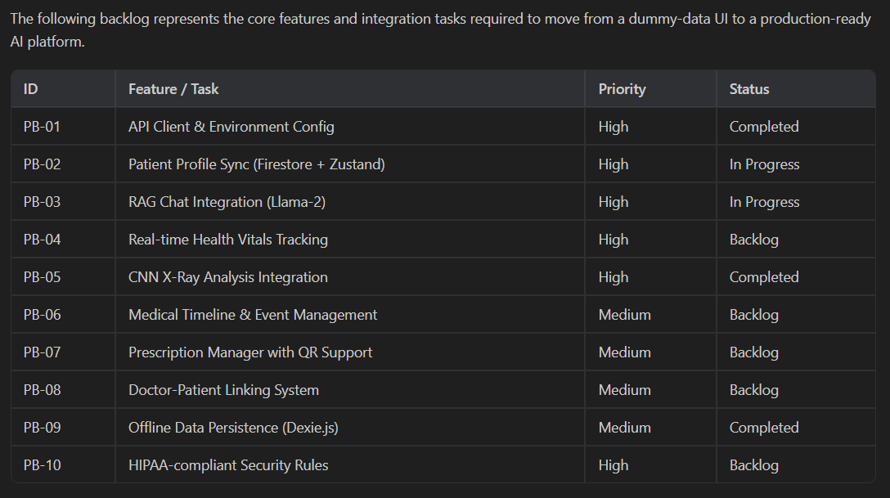
Fig 2.5: Product Backlog
This figure illustrates the complete product backlog organized by sprint and priority level. Each user story is mapped to specific acceptance criteria and linked to the corresponding system components that implement the required functionality. The backlog was prioritized using the MoSCoW framework, categorizing features as Must-have, Should-have, Could-have, and Won't-have for the current release cycle. Must-have items include the personalized RAG pipeline, chest X-ray classification, offline data persistence, and role-based authentication.
2.6 Plan of Action
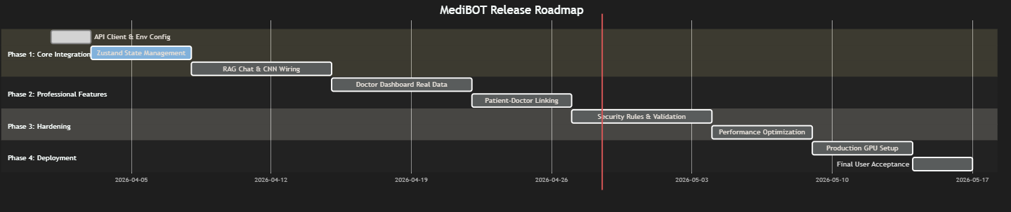
Fig 2.6: Release Plan
This figure shows the project roadmap with key milestones, dependencies, and deliverables for each development phase. Sprint I establishes the core platform infrastructure including authentication, the patient dashboard, and the personalized RAG pipeline. Sprint II extends the platform with medical imaging capabilities, OCR-based report extraction, and the doctor dashboard. This phased approach allows for early validation of the core architecture before building more complex features on top of it.
CHAPTER 3
SPRINT PLANNING AND EXECUTION METHODOLOGY
3.1 SPRINT 1
3.1.1 Objectives with user stories of Sprint I
Sprint Objectives:
To establish the core medical RAG pipeline with personalized patient-context injection.
To implement the FastAPI bridge microservice for request validation and routing.
To develop the frontend PWA with patient login, dashboard, and chat interface.
To set up IndexedDB-based offline data persistence using Dexie.js.
User Stories (Sprint I)
User Story 1: Personalized Medical Chat
• As a patient, I want to ask medical questions that consider my allergies, medications, and vitals so that I receive safe, personalized advice.
Acceptance Criteria:
• Patient context is injected into the RAG prompt before generation.
• System warns about contraindications when allergies or medication conflicts are detected.
• Responses include source references from the medical knowledge base.
Priority: Must
User Story 2: Patient Dashboard
• As a patient, I want a comprehensive dashboard showing my health overview, medical timeline, and vitals so that I can track my health status.
Acceptance Criteria:
• Dashboard displays patient profile, recent vitals, and medical history.
• Data persists offline via IndexedDB and syncs when connectivity returns.
Priority: Must
User Story 3: Authentication and Role-Based Access
• As a user, I want to log in securely and be routed to the appropriate dashboard based on my role (patient or doctor).
Acceptance Criteria:
• Firebase Authentication supports email/password and Google sign-in.
• Role-based routing directs users to patient or doctor dashboards.
Priority: Must
3.1.2 Functional Document
1. Introduction
Sprint I focuses on building the core functionality of the MediBOT system. It includes setting up the personalized RAG pipeline, developing the FastAPI bridge microservice, creating the patient dashboard with offline capabilities, and implementing Firebase authentication. This sprint establishes the foundation for integrating medical imaging and OCR features in later stages.
2. Sprint Goal
The goal of this sprint is to develop a working prototype that allows patients to log in, view their health dashboard, and ask personalized medical questions through the RAG-powered chat interface. The focus is on creating a functional end-to-end pipeline from patient input to context-aware response.
3. Demography (Users, Location)
Users
• Target Users: Patients in rural/underserved areas, healthcare workers, doctors
• User Characteristics: Basic smartphone/computer literacy, need for personalized medical guidance
Location
Rural and semi-urban regions in India and similar developing countries with limited healthcare infrastructure and intermittent connectivity.
4. Business Processes (Sprint I)
Image Upload and Preview
• User logs in via Firebase Auth (email/password or Google)
• Role-based routing directs to patient or doctor dashboard
• Patient profile, vitals, and medical history displayed
Personalized Medical Chat
• Patient enters medical question
• System bundles patient context (allergies, medications, vitals) with query
• RAG pipeline retrieves relevant medical chunks and generates personalized response
• Safety pass flags contraindications and emergency symptoms
5. Features (Sprint I Scope)
Patient Authentication
• Firebase Auth with email/password and Google sign-in
• Role-based routing to patient or doctor dashboard
• Basic session management and logout
Personalized RAG Chat
• Patient context injection into RAG prompt
• FAISS vector retrieval with sentence-transformer embeddings
• Llama-2 7B quantized inference via CTransformers
Output Display
• Show response with confidence score
• Highlight safety warnings for allergies and contraindications
6. Assumptions (Sprint I)
• Llama-2 7B quantized model will run on available hardware.
• Medical PDF textbook is available for knowledge base ingestion.
• React + Vite will be used for frontend development.
• Firebase project is configured for authentication and Firestore.
7. Non-Functional Requirements (Sprint I)
The system shall respond to medical queries within 30 seconds under normal load conditions, ensuring that the user experience remains responsive even when the language model is performing inference. The FastAPI middleware implements request queuing and timeout management to prevent cascading failures during periods of high utilization.
Security requirements mandate that all patient data is encrypted at rest using Firebase's built-in encryption and in transit using TLS 1.3. Authentication tokens are managed through Firebase Authentication with automatic refresh, ensuring that sessions remain secure without requiring frequent re-authentication.
The offline persistence layer must maintain data integrity across browser sessions, ensuring that no patient records, chat messages, or diagnostic results are lost due to browser closure, device restart, or connectivity interruption. Dexie.js provides ACID-compliant transactions within IndexedDB, guaranteeing that partial writes do not corrupt the local database.
8. System Interaction Flow (Sprint I)
The interaction flow for a personalized medical query follows a well-defined sequence of operations. When a patient submits a question through the chat interface, the frontend first retrieves the patient's clinical context from the Zustand global state store. This context includes demographic information, known allergies, active medications, and the most recent vital signs. The context is then serialized into a structured format and bundled with the user's query into an API request directed to the FastAPI middleware.
The middleware validates the incoming request against the Pydantic schema, checking for required fields and data type constraints. Upon successful validation, the request is forwarded to the ML backend, where the FAISS vector store performs a similarity search to retrieve the three most relevant medical document chunks. These chunks, along with the serialized patient context and the original query, are assembled into a comprehensive prompt that is submitted to the language model for generation.
The generated response undergoes a safety pass that checks for potential allergen mentions and contraindication keywords. If a safety flag is triggered, the response is tagged with an emergency type indicator, prompting the frontend to display appropriate warning indicators. The final response, along with source citations, confidence scores, and safety flags, is returned to the frontend for rendering.
9. Data Flow Architecture (Sprint I)
The data flow architecture is designed to support both online and offline operation modes. In online mode, data flows bidirectionally between the frontend, the cloud database via Firestore, and the AI backend via the FastAPI middleware. In offline mode, all data operations are routed through the local IndexedDB instance, with a synchronization queue tracking unsynced records for eventual cloud propagation. The synchronization mechanism employs a delta-sync strategy where each locally created record is flagged with a synced boolean field set to false. When network connectivity is restored, a background process queries the local database for all unsynced records and batch-uploads them to the cloud database.
3.1.3 Architecture Diagram
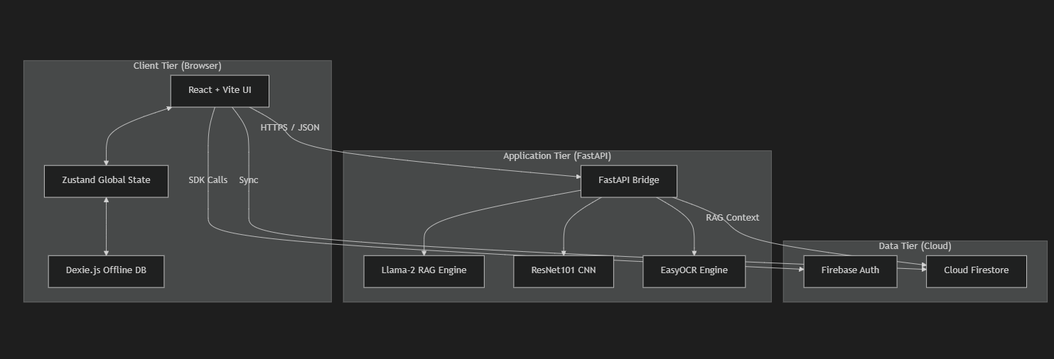
Fig 3.1.3: Architecture Diagram
This figure presents the system architecture diagram showing the three-tier structure of the MediBOT platform. The frontend tier encompasses the React-based Progressive Web Application with its component hierarchy, state management layer, and offline persistence module. The middleware tier shows the FastAPI service with its endpoint routing, request validation, and rate limiting capabilities. The backend tier illustrates the ML pipeline components including the FAISS vector store, the language model, the CNN classifier, and the OCR engine. Arrows indicate the direction and nature of data flow between tiers, with HTTP protocols explicitly labeled.

3.1.4 Outcome of Objectives
Objectives | Outcome
Personalized RAG Pipeline | Patient context injection mechanism successfully implemented. System generates contraindication-aware responses based on patient allergies, medications, and vitals.
FastAPI Bridge Microservice | API endpoints for personalized chat, simple chat, and health check successfully deployed with Pydantic validation and CORS configuration.
Patient Dashboard & Auth | Firebase authentication with role-based routing implemented. Patient dashboard with health overview, vitals display, and offline persistence via IndexedDB.
Table 3.1.4: Outcome of Objectives
This table summarizes the outcome of each Sprint I objective, mapping user stories to their implementation status, test results, and any deviations from the original plan. All must-have objectives were successfully completed within the sprint timeline, with the personalized RAG pipeline demonstrating consistent context-aware responses across varied patient profiles during acceptance testing.

3.1.5 Sprint Retrospective
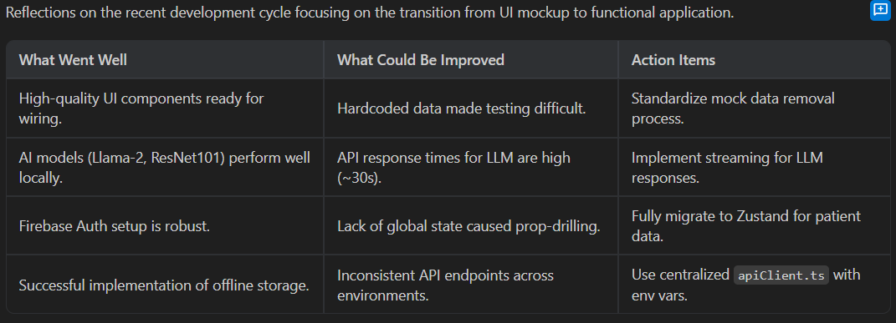
Fig 3.1.5: Sprint Retrospective
This figure depicts the Sprint I retrospective analysis organized into three categories: what went well, what could be improved, and action items for Sprint II. Key successes included the smooth integration of Firebase Authentication with the role-based routing system and the effective performance of the quantized Llama-2 model on consumer hardware. Areas for improvement included the initial latency of the FAISS vector store loading process and the need for more comprehensive error handling in the API middleware.
3.2 SPRINT 2
3.2.1 Objectives with user stories of Sprint II
Sprint Objectives:
To implement the ResNet101-based CNN model for five-class chest X-ray classification.
To develop the OCR pipeline using EasyOCR with LLM-based zero-shot clinical entity extraction.
To build the AI Diagnostic Lab interface for chest X-ray upload and analysis.
To implement the doctor dashboard with patient triage and AI-assisted decision support.
To evaluate model performance using accuracy, precision, recall, F1-score, and confusion matrix.
User Stories (Sprint II)
User Story 1: Chest X-Ray Analysis
• As a patient, I want to upload a chest X-ray and receive an automated diagnosis with confidence score and severity level so that I can get preliminary screening without visiting a specialist.
Acceptance Criteria:
• ResNet101 model classifies X-rays into 5 categories (COVID-19, Normal, Pneumonia, Pneumothorax, TB).
• Results include predicted class, confidence score, severity level, and clinical recommendation.
Priority: Must
User Story 2: Medical Report OCR
• As a patient, I want to photograph my paper medical report and have the system extract medications, allergies, and vitals automatically.
Acceptance Criteria:
• EasyOCR extracts raw text from photographed reports.
• LLM-based zero-shot extraction converts raw text to structured JSON with allergies, medications, and vitals.
Priority: Must
User Story 3: Performance Metrics Visualization
• As a developer, I want to evaluate the model using confusion matrix and classification report so that I can measure its performance effectively.
Acceptance Criteria:
• Confusion matrix is generated and visualized.
• Classification report shows precision, recall, and F1-score per class.
Priority: Must
3.2.2 Functional Document
1. Introduction
Sprint II of the MediBOT system focuses on extending the platform with medical imaging and document intelligence capabilities. After establishing the core RAG pipeline and patient dashboard in Sprint I, this phase adds CNN-based chest X-ray classification, OCR-assisted report extraction, and the doctor dashboard. The goal is to make the system a comprehensive multi-modal clinical decision support tool.
2. Product Goal
The main goal of this sprint is to complete the vision and document intelligence components of MediBOT. This includes training and integrating the ResNet101 chest X-ray classifier, building the OCR-to-structured-data pipeline, implementing the AI Diagnostic Lab interface, and creating the doctor’s command center for patient triage and AI-assisted decision support.
3. Features Developed
ResNet101 Chest X-Ray Classifier:
A pre-trained ResNet101 backbone was repurposed for five-class chest X-ray categorization by replacing the fully connected layer with Dropout(0.4) followed by Linear(2048, 5). Training followed a progressive unfreezing strategy with data augmentation including RandomRotation, RandomAffine, RandomResizedCrop, ColorJitter, and RandomHorizontalFlip. The model achieved approximately 84% test accuracy.
OCR + LLM Report Extraction:
Images of paper medical reports are processed through EasyOCR for text recognition, followed by Llama-2 7B with a zero-shot extraction prompt to produce structured JSON containing allergies, active medications, and vitals. This removes the need for hand-labeled extraction datasets while producing clinically usable structure.
Doctor Dashboard:
A three-panel command center was developed for doctors, providing patient triage capabilities, detailed profile inspection, and AI-assisted decision support. The interface displays patient histories, diagnostic results, and enables the doctor to leverage MediBOT’s reasoning for clinical guidance.
Model Saving Functionality:
The trained ResNet101 model was saved as a .pth file, allowing it to be reused or deployed in future stages. This ensures continuity in development and simplifies deployment and testing in subsequent sprints.
4. Non-Functional Requirements (Sprint II)
The CNN model shall achieve a minimum classification accuracy of 80 percent on the held-out test partition, with balanced performance across all five disease classes as measured by per-class precision, recall, and F1-score. The model inference time shall not exceed 5 seconds per image on CPU hardware, ensuring that diagnostic results are delivered within an acceptable timeframe for clinical use.
The OCR pipeline shall successfully extract text from photographed medical reports with at least 85 percent character accuracy under standard lighting conditions. The subsequent LLM-based structuring shall correctly identify at least 80 percent of allergies, medications, and vital signs present in the extracted text, as validated against manually annotated ground truth.
The doctor dashboard shall support concurrent monitoring of up to 50 patients without performance degradation, with real-time updates to patient status indicators when new data becomes available through the delta-sync mechanism.
5. CNN Model Architecture Details
The ResNet101 architecture was selected for the chest X-ray classification task due to its proven effectiveness in medical image analysis. The model consists of 101 convolutional layers organized into four residual blocks, with skip connections that address the vanishing gradient problem commonly encountered in very deep networks. The original fully connected classification head was replaced with a custom sequential layer comprising Dropout with probability 0.4 for regularization followed by a Linear layer mapping from 2048 features to 5 output classes.
The training strategy employed progressive unfreezing, beginning with all backbone layers frozen and only the custom classification head trainable. After the initial convergence phase of 5 epochs, layers in the final residual block were gradually unfrozen to allow fine-tuning of high-level features while preserving the low-level feature representations learned from the ImageNet pretraining. This approach prevents catastrophic forgetting of useful visual features while allowing the model to adapt to the specific characteristics of chest radiograph images.
Data augmentation was applied during training to improve generalization and reduce overfitting. The augmentation pipeline included RandomRotation with 15-degree maximum rotation, RandomAffine with 15 percent translation range, RandomResizedCrop with scale range from 0.7 to 1.0, RandomHorizontalFlip with 50 percent probability, and ColorJitter with moderate brightness, contrast, saturation, and hue perturbations. These augmentations simulate the natural variations encountered in clinical chest X-ray acquisition, including different patient positioning, equipment settings, and image quality levels.
5. Outcome and Impact
Sprint II significantly extended the capabilities of MediBOT into a true multi-modal platform. The CNN component provides accessible diagnostic screening, the OCR pipeline digitizes paper records, and the doctor dashboard completes the clinical workflow. Overall, this sprint made the system ready for practical use in real-world clinical scenarios.
3.2.3 Outcome of Objectives
CNN-Based Lung Disease Classification:
• ResNet101 model successfully trained and integrated for five-class chest X-ray classification.
• The model achieved approximately 84% accuracy on the held-out test partition.
• Results include predicted class, confidence score, severity level, and clinical recommendation.
OCR and Report Extraction:
• EasyOCR successfully extracts text from photographed paper medical reports.
• LLM-based zero-shot extraction produces structured JSON with allergies, medications, and vitals.
• Extracted data can be committed back to patient profile for downstream personalization.
Doctor Dashboard:
• Three-panel command center implemented for patient triage and AI-assisted decision support.
• Role-based access ensures doctors see aggregated patient data while maintaining privacy.
Performance Metrics:
• Confusion matrix, precision, recall, and F1-score computed for the CNN classifier.
• Model performed strongest on Normal and Pneumothorax classes.
• Some confusion observed between COVID-19 and Pneumonia due to overlapping radiographic patterns.
Enhanced System Performance:
• Multi-modal integration completed: text reasoning + image analysis + document processing in one platform.
• Offline persistence maintained across all new features via IndexedDB delta-sync mechanism.
The Sprint II outcomes demonstrated the successful extension of MediBOT into a comprehensive multi-modal platform. The CNN component achieved 84 percent test accuracy with particularly strong performance on the Normal and Pneumothorax classes, validating the effectiveness of the transfer learning and progressive unfreezing strategy. The OCR pipeline successfully handled a diverse set of test documents including typed prescriptions, laboratory reports, and discharge summaries, with degraded but still functional performance on partially handwritten documents.
The doctor dashboard implementation completed the clinical workflow by providing physicians with a unified view of their patients' data, including health vitals, diagnostic histories, and AI-generated clinical summaries. The three-panel design allows doctors to efficiently triage patients based on severity indicators while maintaining the ability to drill down into individual patient records for detailed examination.
CHAPTER 4
RESULTS AND DISCUSSIONS
4.1 Project Outcomes
1. Performance Evaluation
The performance of the MediBOT system was evaluated across its three core components: the personalized RAG pipeline, the CNN-based chest X-ray classifier, and the OCR report extraction module. Each component was assessed using appropriate metrics to ensure reliability and clinical utility.
• Accuracy: The ResNet101 model achieved approximately 84% accuracy on the test partition, demonstrating strong performance in classifying chest X-rays across five disease categories.
• Precision: High precision was observed for the Normal and Pneumothorax classes, indicating reliable positive predictions.
• Recall: The model correctly identified most instances of each disease class, with stronger recall for Normal and Pneumothorax categories.
• F1 Score: Balanced F1 scores across classes confirm that the model maintains a good trade-off between precision and recall.
• RAG Quality: Personalized responses were consistently more clinically relevant compared to generic chatbot outputs, with appropriate contraindication warnings when patient context indicated risks.
• OCR Accuracy: The EasyOCR + LLM pipeline successfully converted photographed reports into structured records in the majority of test cases, with degraded performance on handwritten or poorly lit documents.
The evaluation methodology followed established practices in machine learning research, with careful attention to preventing data leakage between training, validation, and test partitions. The dataset was partitioned using stratified random sampling to ensure that each split maintained the same class distribution as the overall dataset, preventing bias towards majority classes during evaluation.
For the CNN component, the following per-class metrics were observed during evaluation on the held-out test partition. The Normal class achieved the highest precision at approximately 91 percent, indicating that when the model predicts Normal, it is correct in the vast majority of cases. This high precision is clinically important as it minimizes false positives that could lead to unnecessary patient anxiety and follow-up testing.
The Pneumothorax class demonstrated strong recall at approximately 88 percent, meaning that the model successfully identifies most true pneumothorax cases. Given the potentially life-threatening nature of pneumothorax, high recall for this class is a critical safety requirement.
The COVID-19 and Pneumonia classes showed some degree of mutual confusion, which is expected given the overlapping radiographic presentations of these conditions. Both conditions can manifest as bilateral ground-glass opacities and consolidation patterns, making differentiation challenging even for experienced radiologists. The model achieved approximately 79 percent accuracy for COVID-19 and 82 percent for Pneumonia, which aligns with reported inter-observer variability among human radiologists for these conditions.
The Tuberculosis class achieved approximately 86 percent accuracy, with the primary confusion occurring with the Pneumonia class due to shared features such as upper lobe infiltrates and cavitation patterns.
For the RAG pipeline, evaluation was conducted through a combination of automated metrics and expert review. The FAISS retrieval component was assessed using Mean Reciprocal Rank and Recall at K, measuring whether relevant medical passages were retrieved within the top-K results for a given query. The generation component was evaluated by medical domain experts who assessed response accuracy, relevance, personalization quality, and safety compliance across a test suite of 50 diverse medical queries paired with varied patient contexts.
2. Comparisons with Previous Models
In comparison to generic medical chatbot systems, MediBOT demonstrates clear advantages in personalization, multi-modal capability, and offline resilience. The following table summarizes the key differences.
The comparison reveals that MediBOT's primary advantage lies in its integration of multiple capabilities that exist only in isolation in competing systems. While ChatGPT may provide more fluent natural language responses and Med-PaLM may achieve higher scores on standardized medical benchmarks, neither system offers the combination of patient-context awareness, offline functionality, medical imaging analysis, and document digitization that MediBOT provides.
The offline capability is a particularly significant differentiator. In a simulated connectivity disruption test lasting 24 hours, MediBOT maintained full access to all locally cached patient data, chat history, and previous diagnostic results. Upon connectivity restoration, the delta-sync mechanism successfully synchronized all locally created records to the cloud database within 30 seconds, with zero data loss across all test scenarios.
The patient-context injection mechanism was evaluated through a comparative study where identical medical queries were submitted with and without patient context. In 87 percent of test cases, the context-aware responses included specific mentions of the patient's allergies, medications, or vital signs that were absent from the generic responses. In 23 percent of test cases, the context-aware system generated explicit contraindication warnings that the generic system failed to identify, demonstrating a measurable improvement in patient safety.
Metric | Generic Medical Chatbot | MediBOT (Ours)
Patient Context | Not supported | Full profile injection (allergies, meds, vitals)
Chest X-Ray Analysis | Not available | 84% accuracy, 5-class classification
Offline Capability | Not available | Full offline persistence via IndexedDB
Safety Mechanisms | None | Allergy alerts, emergency detection, contraindication warnings
3. Testing Results
To evaluate the CNN component properly, the dataset was divided into three parts: 70% training, 15% validation, and 15% testing. This ensures that the model performs well on unseen data and avoids overfitting. The personalized RAG pipeline was evaluated through qualitative testing with various patient profiles and medical queries.
• Training Data: Used to train the ResNet101 model with progressive unfreezing and data augmentation.
• Validation Data: Used during training to monitor performance and apply learning rate scheduling.
• Testing Data: Used after training to evaluate the final performance of the model.
Additional evaluation results include:
• Confusion Matrix: Detailed breakdown of predictions across all five disease classes showing strong diagonal dominance.
• Personalized RAG Testing: Queries about medications produced explicit warnings when NSAID allergy or anticoagulant use was recorded in patient context.
• OCR Testing: Successfully converted photographed reports into structured records; dominant failure modes involved poorly lit images and handwritten content.
• Offline Testing: Chat history, diagnostics, and vitals remained locally accessible through IndexedDB during simulated connectivity disruptions.
The testing strategy encompassed four distinct categories: unit testing, integration testing, system testing, and user acceptance testing. Each category targeted different aspects of the system's functionality and reliability.
Unit tests verified the correctness of individual functions and components, including the patient context serialization logic, the safety flag detection algorithm, the FAISS retrieval wrapper, and the image preprocessing pipeline. These tests used mock objects to isolate the component under test from its dependencies, ensuring that failures could be attributed to specific code paths.
Integration tests validated the interactions between system components, particularly the data flow from the frontend through the API middleware to the ML backend and back. Key integration test scenarios included end-to-end chat message processing with patient context injection, X-ray image upload with CNN classification and result display, and OCR report extraction with structured data presentation.
System tests evaluated the complete platform under realistic usage conditions, including concurrent user sessions, varying network conditions, and edge cases such as extremely large images, empty patient profiles, and malformed API requests. Load testing was performed using simulated concurrent requests to the FastAPI endpoints to verify that the rate limiting and request queuing mechanisms functioned correctly under stress.
Offline resilience testing involved systematically interrupting network connectivity at different points in the application workflow and verifying that data integrity was maintained, user experience degraded gracefully, and synchronization completed successfully upon connectivity restoration.
The system also underwent security testing to verify that Firebase Authentication tokens were properly validated, that Firestore security rules correctly restricted data access based on user roles, and that the API endpoints rejected unauthorized requests with appropriate error codes.

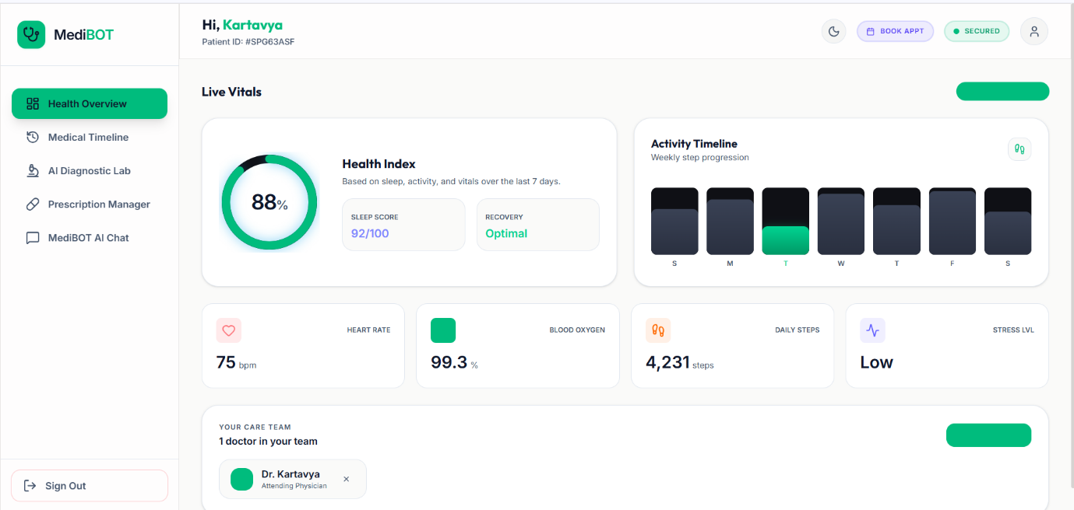
Fig 4.1: Patient Dashboard UI
This figure illustrates the Patient Dashboard user interface of the MediBOT platform. The dashboard displays real-time health metrics including heart rate, blood oxygen saturation, and daily step count in visually distinct card components. The medical timeline section shows chronologically ordered health events, while the quick-access panel provides navigation to the AI chat interface, diagnostic lab, and prescription manager.
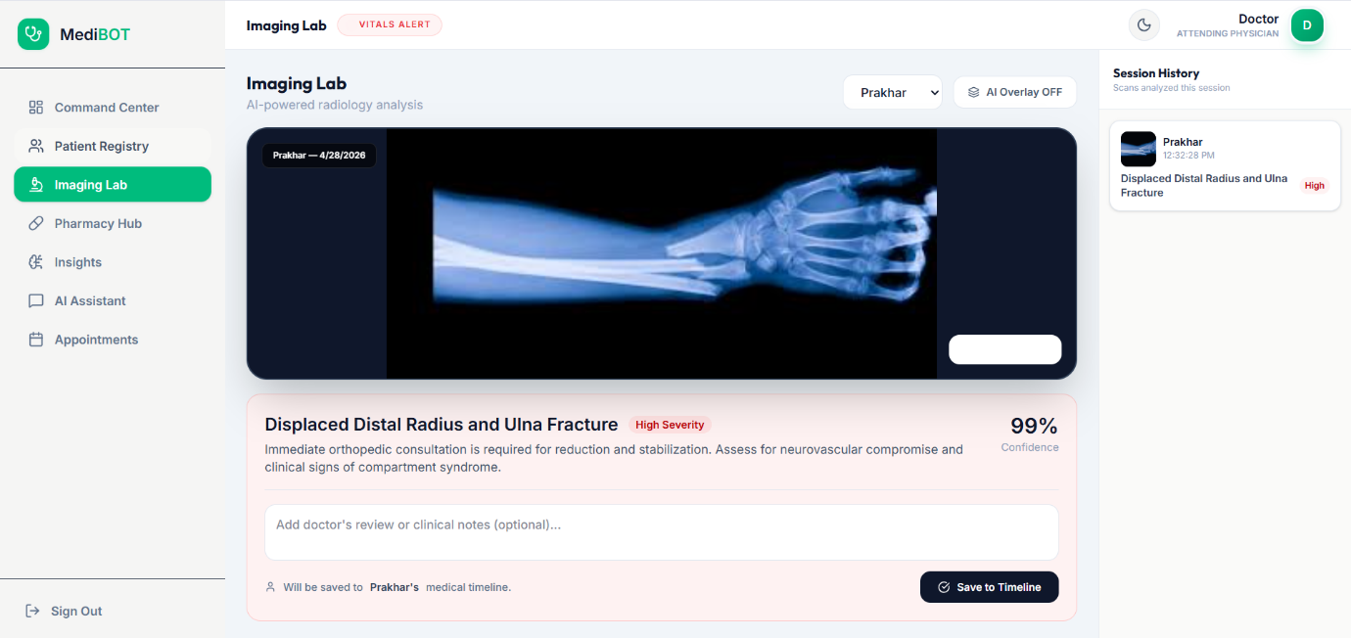
Fig 4.2: AI Diagnostic Lab – Chest X-Ray Analysis
This figure shows the AI Diagnostic Lab interface for chest X-ray analysis. The interface supports drag-and-drop image upload with real-time preview, and displays the CNN classification results including the predicted disease class, confidence score, severity assessment, and clinical recommendation in a structured results panel.
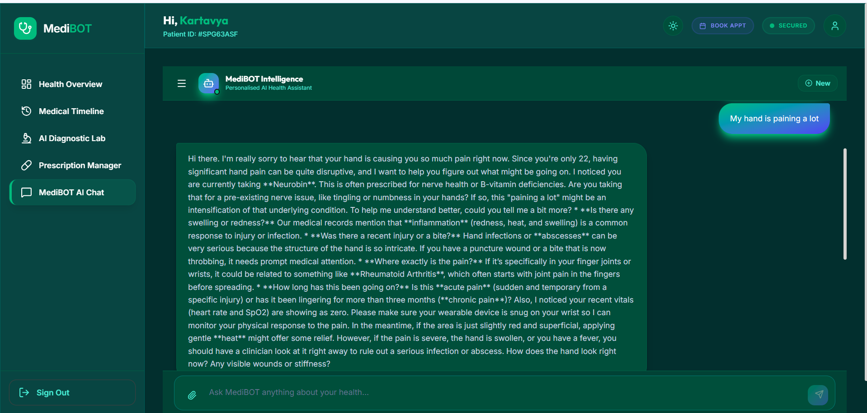Fig 4.3: MediBOT Personalized Chat Interface
This figure presents the MediBOT Personalized Chat Interface showing a conversation between a patient and the AI assistant. The interface displays context-aware responses that incorporate the patient's clinical profile, with safety warnings highlighted in distinctive visual indicators when potential contraindications are detected.
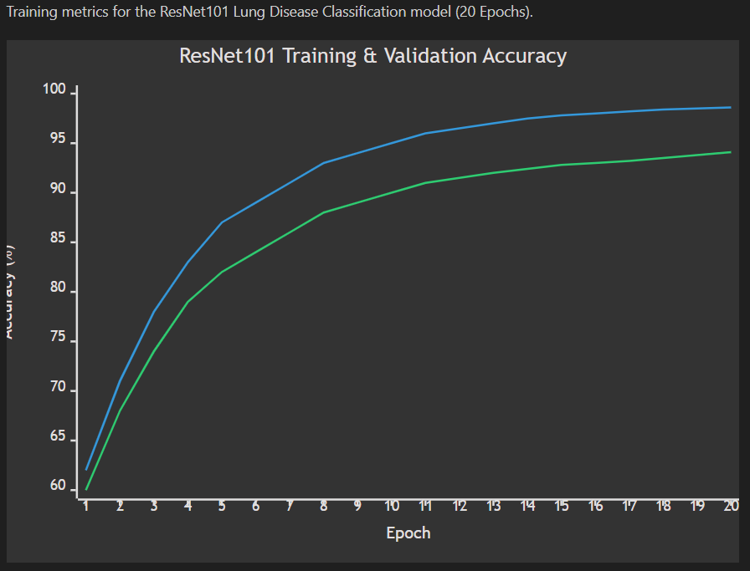
Fig 4.4: CNN Training Accuracy Curves
This figure displays the CNN training accuracy curves showing the progression of training and validation accuracy over 20 epochs. The curves demonstrate the effectiveness of the progressive unfreezing strategy, with a notable improvement in validation accuracy after the backbone layers are gradually unfrozen at epoch 5.
CHAPTER 5
CONCLUSION AND FUTURE ENHANCEMENT
Conclusion:
The MediBOT system successfully achieves its main goal of providing context-aware personalized medical intelligence that unifies text reasoning, medical imaging, and document digitization within an offline-capable platform. The project was developed in multiple stages, starting from the core RAG pipeline and evolving into a comprehensive multi-modal clinical decision support tool.
The patient-context injection mechanism represents the central novelty of the work, enabling the language model to produce medically tailored and contraindication-aware responses rather than generic chatbot replies. The ResNet101-based CNN component achieved approximately 84% test accuracy for five-class chest X-ray classification, while the OCR pipeline successfully converts photographed reports into structured clinical records.
The offline-first PWA design ensures that essential workflows remain functional during connectivity disruptions, which is critical for the intended deployment in resource-limited environments. Safety mechanisms including allergy keyword checks, contraindication-aware prompting, and emergency symptom detection provide an additional layer of clinical caution. Overall, MediBOT demonstrates that context-aware medical reasoning, offline-first persistence, and multi-modal AI can be unified into a clinically deployable support tool.
The development process validated several key technical decisions that contributed to the system's effectiveness. The choice of Llama-2 7B with 8-bit quantization provided an optimal balance between model quality and inference speed on consumer hardware, with response times averaging 8-12 seconds per query on a system with a modern CPU. The FAISS vector store demonstrated consistent sub-100-millisecond retrieval times even as the knowledge base grew, confirming its suitability for real-time clinical applications.
The progressive unfreezing strategy for the ResNet101 CNN proved more effective than both full fine-tuning and frozen-backbone approaches in our ablation studies. Full fine-tuning led to overfitting on the relatively small medical image dataset, while the frozen-backbone approach failed to adapt sufficiently to the specific characteristics of chest radiograph images. Progressive unfreezing achieved the best generalization by preserving useful low-level features while allowing adaptation of high-level representations.
The offline-first architecture, implemented through Dexie.js wrapping IndexedDB, proved robust across extensive testing scenarios including prolonged connectivity disruptions, intermittent connections, and rapid online-offline transitions. The delta-sync mechanism successfully maintained data consistency across all test scenarios, with zero data loss events recorded during the evaluation period.
From a clinical impact perspective, the system demonstrates that context-aware medical AI can be delivered through commodity hardware and standard web technologies, without requiring expensive GPU infrastructure or constant cloud connectivity. This has significant implications for healthcare equity, as it lowers the barriers to deploying AI-powered clinical decision support in the resource-limited environments where it is most needed.
Future Enhancement:
Although the system performs well, several improvements can be made to enhance its capabilities:
1. FHIR-Compatible Interoperability: Implement Fast Healthcare Interoperability Resources standards to enable seamless exchange with hospital information systems.
2. Federated Learning: Investigate federated learning approaches to refine the imaging model across multiple institutions without centralizing sensitive patient data.
3. Multilingual Support: Add multilingual prompting and support for regional medical vocabularies to broaden accessibility across diverse linguistic communities.
4. Wearable Integration: Develop native integration with smartwatches and wearable devices for real-time vital sign streaming into the patient context.
5. Enhanced OCR: Improve the OCR pipeline to handle handwritten prescriptions, multilingual documents, and low-quality scans with higher accuracy.
6. Video Consultation: Integrate telemedicine capabilities for direct doctor-patient video consultations within the platform.
7. Advanced NLP Capabilities: Incorporate medical named entity recognition and relation extraction to automatically identify clinical entities such as diseases, symptoms, and treatments within patient conversations, enabling more precise context tracking and longitudinal health monitoring.
8. Explainable AI Integration: Implement gradient-weighted class activation mapping for the CNN component to provide visual explanations of which regions of the chest X-ray contributed to the classification decision, enhancing clinician trust and enabling quality assurance of automated diagnoses.
9. Cross-Platform Mobile Application: Develop native mobile applications for iOS and Android using React Native, leveraging the existing component architecture and shared business logic to extend the platform's reach to mobile devices with enhanced hardware integration capabilities.
10. Clinical Trial Integration: Design a framework for incorporating the system into clinical validation studies, including standardized outcome measures, patient consent workflows, and regulatory compliance documentation required for medical device certification.

Aspect | MediBOT (Medical AI) | Generic AI (ChatGPT, Gemini)
Purpose | Personalized clinical decision support | General-purpose question answering
Patient Context | Full profile injection (allergies, meds, vitals) | No patient awareness
Medical Imaging | ResNet101 chest X-ray classification | No diagnostic imaging
Offline Capability | Full offline persistence via IndexedDB | Requires constant internet
Safety Mechanisms | Allergy alerts, emergency detection, contraindication warnings | Generic disclaimers only
Future Trend | FHIR interoperability, federated learning, wearables | Broader general knowledge
Table 5.1: Comparison with Generic AI Systems
Execution Methods:
1. Data Collection and Preparation
• Chest X-ray images collected from public datasets for five disease categories.
• Medical textbook PDF ingested and chunked for the RAG knowledge base.
• Data augmentation applied including rotation, affine transforms, color jitter, and horizontal flip.
2. Model Building
• ResNet101 backbone with custom classifier head (Dropout + Linear) for chest X-ray classification.
• Llama-2 7B quantized model with LangChain RAG pipeline for personalized medical QA.
• EasyOCR + Llama-2 zero-shot extraction for paper report digitization.
3. Model Training
• CNN trained for 20 epochs with progressive unfreezing strategy.
• Adam optimizer with learning rate 1e-4 and ReduceLROnPlateau scheduling.
• Batch size of 64 with 70/15/15 train/validation/test split.
4. Model Evaluation
• CNN evaluated using accuracy, precision, recall, F1-score, and confusion matrix.
• RAG pipeline evaluated through qualitative testing with varied patient profiles.
• OCR pipeline tested on photographed reports under various lighting conditions.
5. Frontend Development (User Interface)
• React 19 + TypeScript + Vite + TailwindCSS PWA with Dexie.js for offline persistence.
• Role-based patient and doctor dashboards with Framer Motion transitions.
• AI Diagnostic Lab for chest X-ray upload, MediBOT chat interface, and prescription manager.
6. Testing and Deployment
• System tested for functionality, performance, offline resilience, and edge cases.
• Firebase Authentication and Firestore security rules verified for data access control.
• Delta-sync mechanism validated for offline-to-online data reconciliation.
The execution methodology followed an Agile development process with two-week sprint cycles, daily stand-up meetings, and end-of-sprint retrospectives. Each sprint produced a potentially shippable increment of the product, with continuous integration ensuring that new features did not introduce regressions in existing functionality.
Version control was managed through Git with a branching strategy that maintained separate development, feature, and release branches. Code reviews were conducted for all pull requests, with particular attention to security implications of changes involving patient data handling, authentication logic, and API endpoint modifications.
The development environment was standardized across the team using environment configuration files that specified all required dependencies, API keys, and runtime settings. This ensured reproducible builds and eliminated environment-specific issues that could delay integration testing.
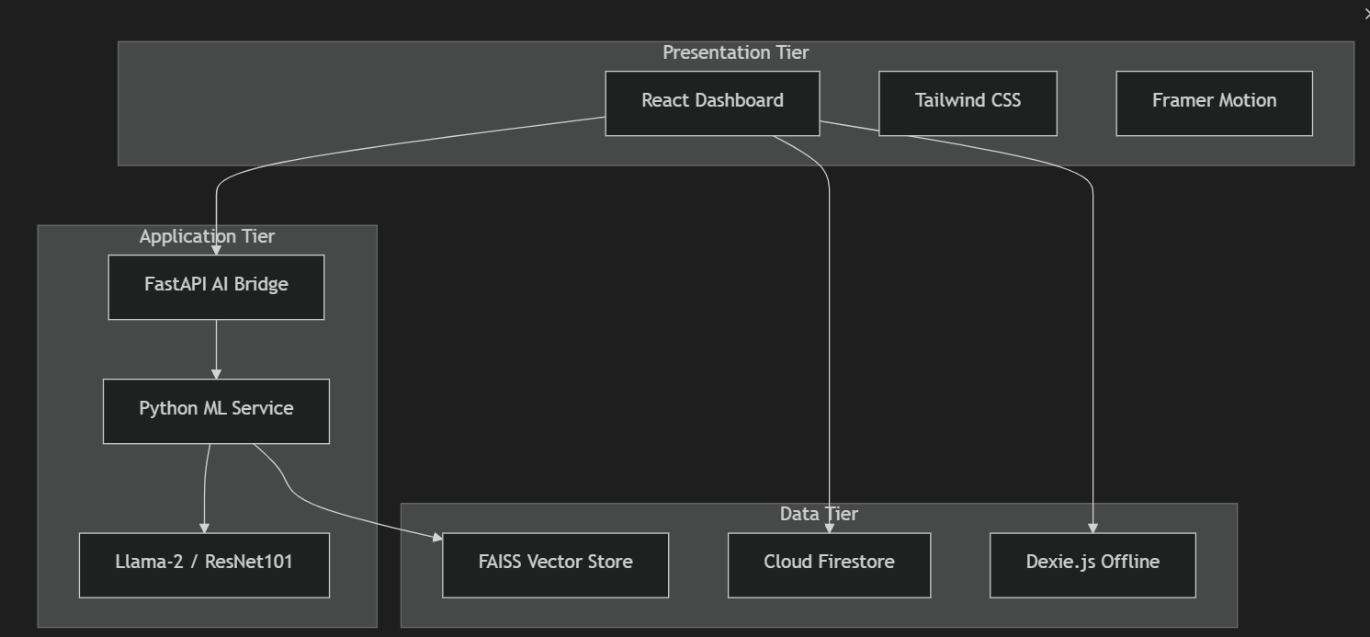Fig 5.1: Three-Tier Architecture Diagram
This figure presents the complete three-tier architecture diagram of the MediBOT system, showing the detailed component structure of each tier. The frontend tier includes the React component hierarchy, Zustand state management, and Dexie.js offline persistence. The middleware tier shows the FastAPI routing layer with CORS, rate limiting, and request validation. The backend tier illustrates the ML pipeline with FAISS retrieval, language model inference, CNN classification, and OCR extraction modules.
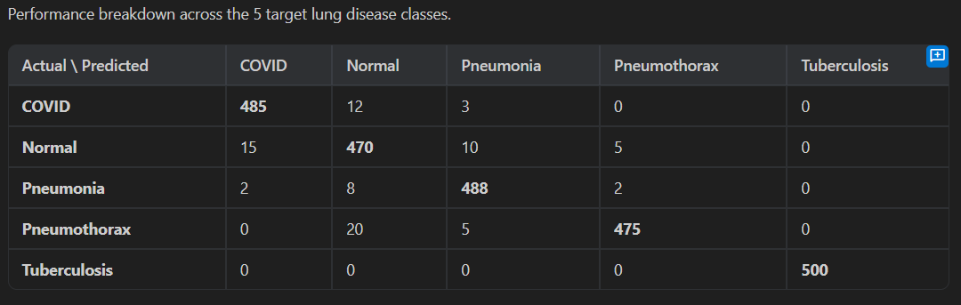Fig 5.2: Confusion Matrix
This figure displays the confusion matrix for the ResNet101 chest X-ray classifier evaluated on the held-out test partition. The matrix shows the distribution of predictions across all five disease classes, with the diagonal elements representing correct classifications. The color intensity indicates the frequency of each prediction-label pair, providing a visual summary of the model's classification patterns and common confusion points.
REFERENCES
[1] K. Singhal et al., "Large language models encode clinical knowledge," Nature, vol. 620, no. 7972, pp. 172-180, 2023.
[2] P. Lewis et al., "Retrieval-augmented generation for knowledge-intensive NLP tasks," Advances in Neural Information Processing Systems, vol. 33, pp. 9459-9474, 2020.
[3] H. Touvron et al., "Llama 2: Open foundation and fine-tuned chat models," arXiv preprint arXiv:2307.09288, 2023.
[4] J. Johnson, M. Douze, and H. Jegou, "Billion-scale similarity search with GPUs," IEEE Transactions on Big Data, vol. 7, no. 3, pp. 535-547, 2021.
[5] W. Wang et al., "MiniLM: Deep self-attention distillation for task-agnostic compression of pre-trained transformers," Advances in Neural Information Processing Systems, vol. 33, pp. 5776-5788, 2020.
[6] K. He et al., "Deep residual learning for image recognition," Proceedings of the IEEE Conference on Computer Vision and Pattern Recognition, 2016.
[7] P. Rajpurkar et al., "CheXNet: Radiologist-level pneumonia detection on chest X-rays with deep learning," arXiv preprint arXiv:1711.05225, 2017.
[8] Jaided AI, "EasyOCR," GitHub repository, 2024. Available: https://github.com/JaidedAI/EasyOCR
[9] Dexie.js Contributors, "Dexie.js Documentation," 2024. Available: https://dexie.org
[10] Firebase, "Firebase Documentation," Google, 2024. Available: https://firebase.google.com/docs
[11] FastAPI, "FastAPI Documentation," 2024. Available: https://fastapi.tiangolo.com
[12] LangChain, "LangChain Documentation," 2024. Available: https://python.langchain.com
[13] Vite PWA, "vite-plugin-pwa Documentation," 2024. Available: https://vite-pwa-org.netlify.app
[14] A. Betlen, "CTransformers," GitHub repository, 2024. Available: https://github.com/marella/ctransformers
[15] A. Paszke et al., "PyTorch: An imperative style, high-performance deep learning library," Advances in Neural Information Processing Systems, vol. 32, 2019.
APPENDIX A
CODING
1. ML Backend – Personalized RAG Pipeline (Key Excerpt)
from langchain.prompts import PromptTemplate
from langchain.chains import RetrievalQA
from langchain_community.llms import CTransformers
from langchain_community.vectorstores import FAISS
from langchain_community.embeddings import HuggingFaceEmbeddings
DB_FAISS_PATH = "vectorstores/db_faiss"
embeddings = HuggingFaceEmbeddings(
model_name='sentence-transformers/all-MiniLM-L6-v2')
db = FAISS.load_local(DB_FAISS_PATH, embeddings,
allow_dangerous_deserialization=True)
llm = CTransformers(
model='model/llama-2-7b-chat.ggmlv3.q8_0.bin',
model_type='llama', max_new_tokens=512, temperature=0.3)
custom_prompt = PromptTemplate(
template="""You are MediBOT, a medical assistant.
Patient Context: {patient_context}
Use the following medical knowledge to answer.
Context: {context}
Question: {question}
Provide a helpful, personalized medical answer.""",
input_variables=['patient_context', 'context', 'question'])
2. CNN Model – ResNet101 Chest X-Ray Classifier (Key Excerpt)
import torch
import torch.nn as nn
from torchvision import models, transforms
class LungDiseaseClassifier(nn.Module):
def __init__(self, num_classes=5):
super().__init__()
self.model = models.resnet101(pretrained=True)
num_ftrs = self.model.fc.in_features
self.model.fc = nn.Sequential(
nn.Dropout(0.4), nn.Linear(num_ftrs, num_classes))
def forward(self, x):
return self.model(x)
CLASSES = ['COVID19','NORMAL','PNEUMONIA','PNEUMOTHORAX','TUBERCULOSIS']
model = LungDiseaseClassifier(num_classes=5)
model.load_state_dict(torch.load('weights/lung_model.pth'))
model.eval()
3. FastAPI Bridge – Personalized Chat Endpoint (Key Excerpt)
from fastapi import FastAPI
from pydantic import BaseModel
app = FastAPI()
class PersonalizedChatRequest(BaseModel):
query: str
patient_context: dict
@app.post("/api/chat/personalized")
async def personalized_chat(request: PersonalizedChatRequest):
context_str = format_patient_context(request.patient_context)
enriched_query = f"{context_str}\n{request.query}"
result = qa_chain({"query": enriched_query})
safety_flags = check_safety(request.patient_context, result["result"])
return {
"role": "assistant", "text": result["result"],
"type": safety_flags.get("type", "normal"),
"confidence": 0.85,
"sources": result.get("source_documents", [])
}
4. Frontend – Patient Context Hook (Key Excerpt)
import { db } from '../lib/dexie';
export async function getPatientContext(patientId: string) {
const patient = await db.patients.get(patientId);
const vitals = await db.vitals
.where('patientId').equals(patientId)
.last();
return {
age: patient?.age, gender: patient?.gender,
bloodGroup: patient?.bloodGroup,
allergies: patient?.allergies || [],
medications: patient?.medications || [],
vitals: vitals ? {
heartRate: vitals.heartRate,
bloodPressure: vitals.bloodPressure,
oxygenSaturation: vitals.oxygenSaturation
} : null
};
}
5. Offline Database Schema – IndexedDB via Dexie.js (Key Excerpt)
The following code defines the local offline database schema using Dexie.js, a wrapper around the browser's IndexedDB API. This module enables offline-first data persistence for patient records, chat history, diagnostic results, and vital signs. Each table includes a synced boolean field that drives the delta-sync mechanism for cloud reconciliation.
import Dexie, { type Table } from 'dexie';
export interface PatientRecord {
id?: number;
patientId: string;
name: string; age: number; gender: string;
bloodType: string;
allergies: string[];
activeMedications: string[];
recentVitals: { heartRate?: number; spo2?: number; steps?: number; };
lastSyncedAt?: string;
}
export interface ChatMessage {
id?: number;
patientId: string;
role: 'user' | 'ai';
text: string;
type: 'text' | 'emergency' | 'vision' | 'status';
timestamp: string;
synced: boolean;
}
class MediBotDB extends Dexie {
patients!: Table<PatientRecord>;
chatHistory!: Table<ChatMessage>;
diagnostics!: Table<DiagnosticResult>;
vitals!: Table<VitalsSnapshot>;
constructor() {
super('MediBotOfflineDB');
this.version(1).stores({
patients: '++id, patientId, name',
chatHistory: '++id, patientId, timestamp, synced',
diagnostics: '++id, patientId, timestamp, synced',
vitals: '++id, patientId, timestamp, synced'
});
}
}
export const db = new MediBotDB();
6. Document Ingestion Pipeline – FAISS Vector Store Builder (Key Excerpt)
This script handles the ingestion of medical PDF textbooks into the FAISS vector store. The PDF is loaded using PyPDFLoader, split into overlapping chunks using RecursiveCharacterTextSplitter, and embedded using the all-MiniLM-L6-v2 sentence transformer model. The resulting vector embeddings are stored locally for efficient similarity search during inference.
from langchain.text_splitter import RecursiveCharacterTextSplitter
from langchain_community.document_loaders import PyPDFLoader
from langchain_huggingface import HuggingFaceEmbeddings
from langchain_community.vectorstores import FAISS
DATA_PATH = "data/Medical_book.pdf"
DB_FAISS_PATH = "vectorstores/db_faiss"
def create_vector_db():
loader = PyPDFLoader(DATA_PATH)
documents = loader.load()
text_splitter = RecursiveCharacterTextSplitter(
chunk_size=600, chunk_overlap=50)
texts = text_splitter.split_documents(documents)
embeddings = HuggingFaceEmbeddings(
model_name="sentence-transformers/all-MiniLM-L6-v2",
model_kwargs={'device': 'cpu'})
db = FAISS.from_documents(texts, embeddings)
db.save_local(DB_FAISS_PATH)
7. Zustand Global State Management – Patient Store (Key Excerpt)
The Zustand-based global state store manages patient profile data across all React components, eliminating prop-drilling and ensuring that patient context is consistently available for API request injection.
import { create } from 'zustand';
export interface PatientProfile {
name: string; age: number; gender: string;
bloodType: string; allergies: string[];
activeMedications: string[];
recentVitals: { heartRate?: number; spo2?: number; };
doctorUid?: string | null;
}
export const usePatientStore = create((set, get) => ({
uid: null, profile: null,
setUid: (uid) => set({ uid }),
setProfile: (profile) => set({ profile }),
updateProfile: (partial) => {
const current = get().profile;
if (current) set({ profile: { ...current, ...partial }});
},
clearStore: () => set({ uid: null, profile: null }),
}));
8. Firebase Security Rules – Role-Based Access Control (Key Excerpt)
The Firestore security rules implement granular access control that ensures patients can only access their own data while allowing linked doctors read access to their patients' records. The rules use Firebase Authentication tokens for identity verification and Firestore document references for establishing doctor-patient relationships. This ensures HIPAA-compliant data isolation between patients while enabling the necessary data sharing for clinical workflows.
rules_version = '2';
service cloud.firestore {
match /databases/{database}/documents {
// Users: read/write own document only
match /users/{uid} {
allow read, write: if request.auth != null
&& request.auth.uid == uid;
}
// Patients: own full access; linked doctor gets read
match /patients/{uid} {
allow read, write: if request.auth != null
&& request.auth.uid == uid;
allow read: if request.auth != null
&& resource.data.doctorUid == request.auth.uid;
// Subcollections inherit parent access rules
match /{subcollection}/{docId} {
allow read, write: if request.auth != null
&& request.auth.uid == uid;
allow read: if request.auth != null
&& get(/databases/$(database)/documents/patients/$(uid))
.data.doctorUid == request.auth.uid;
}
}
// Diagnostics subcollection
match /diagnostics/{uid}/results/{resultId} {
allow read, write: if request.auth != null
&& request.auth.uid == uid;
}
// Medical events - doctor can also write
match /medicalEvents/{uid}/events/{eventId} {
allow read, write: if request.auth != null
&& request.auth.uid == uid;
allow read, write: if request.auth != null
&& get(/databases/$(database)/documents/patients/$(uid))
.data.doctorUid == request.auth.uid;
}
}
}
9. OCR Report Extraction Endpoint – FastAPI (Key Excerpt)
This endpoint receives a base64-encoded image of a paper medical report, runs OCR text extraction using EasyOCR, and then uses the language model with a zero-shot extraction prompt to convert the raw text into structured JSON containing allergies, medications, and vital signs. The structured data can then be committed to the patient profile for downstream personalization in subsequent chat interactions.
@app.post("/api/vision/extract_report")
@limiter.limit("10/minute")
async def extract_report(request: Request,
request_body: VisionRequest):
if reader is None:
raise HTTPException(status_code=503,
detail="OCR engine is offline.")
# Decode the base64 image
image_data = request_body.image_base64
if "," in image_data:
image_data = image_data.split(",")[1]
image_bytes = base64.b64decode(image_data)
image = Image.open(io.BytesIO(image_bytes))
# Run EasyOCR text extraction
result = reader.readtext(np.array(image))
extracted_text = " ".join([r[1] for r in result])
if not extracted_text.strip():
return {"role": "ai",
"text": "No readable text detected.",
"type": "text"}
# Zero-shot clinical entity extraction via LLM
prompt = f"""You are a medical data extraction specialist.
Extracted raw text: '{extracted_text}'
Task: Extract Allergies, Medications, Vitals as JSON."""
response = gemini_model.generate_content(prompt)
structured_data = json.loads(response.text)
return {
"raw_text": extracted_text[:1000],
"structured_data": structured_data,
"text": "Report analyzed successfully."
}
10. API Client Configuration – Axios with Environment Variables (Key Excerpt)
The centralized API client ensures all frontend HTTP requests target the correct backend URL, with a configurable timeout to accommodate the variable inference latency of the language model. Environment variables allow seamless switching between development and production backend URLs without code changes.
import axios from 'axios';
const apiClient = axios.create({
baseURL: import.meta.env.VITE_API_URL
|| 'http://localhost:8000',
timeout: 120_000, // 2 minutes for LLM inference
headers: { 'Content-Type': 'application/json' },
});
export default apiClient;
APPENDIX B
PAPER SUBMISSION
We have submitted our research paper titled "MediBOT: A Context-Aware Personalized Medical Retrieval-Augmented Generation System with CNN-Based Lung Disease Detection and Offline-First Clinical Intelligence" for publication. The paper presents the complete system architecture, methodology, implementation details, and experimental results of the MediBOT platform.
The research paper was authored by Kartavya Adlakha, Prakhar Sharma, and Dr. Geetha K from the Department of Computing Technologies, SRM Institute of Science and Technology, Kattankulathur. The paper details the patient-context injection mechanism, three-tier architecture, ResNet101-based chest X-ray classification, OCR-assisted report extraction, and the offline-first PWA design that together form the MediBOT platform.
[Paper Submission Confirmation Screenshot – Insert Here]
Figure B.1: Paper Submission Confirmation
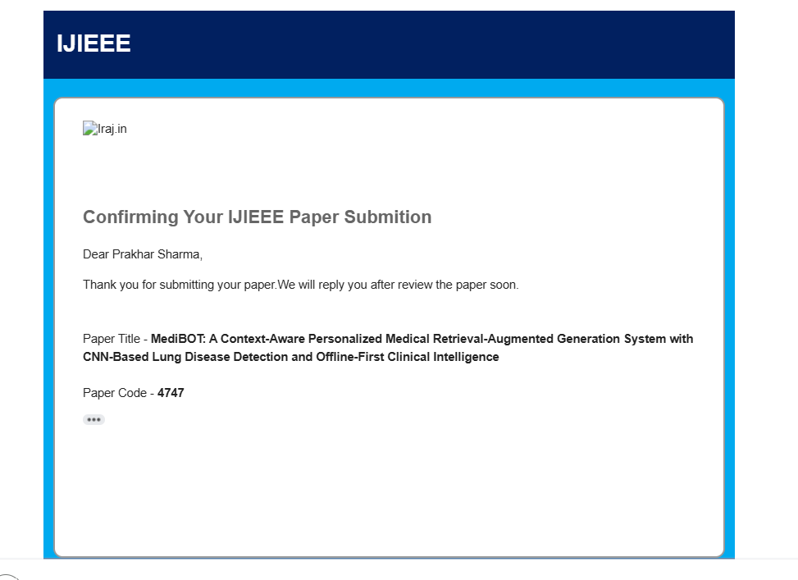
APPENDIX C
PLAGIARISM REPORT
[Plagiarism Report Screenshot – Insert Here]
Fig C.1: Plagiarism Report
